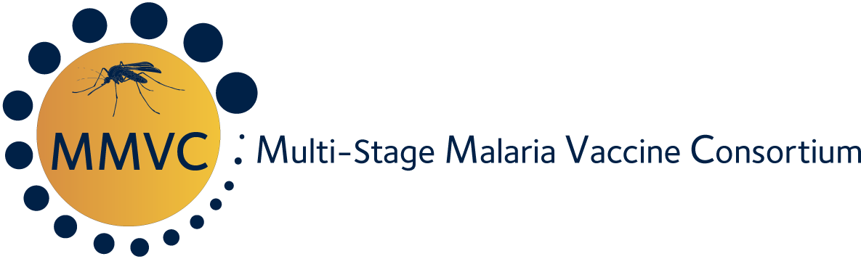

**DESCRIPTION OF FELLOWSHIPS**

**Multi-Stage Malaria Vaccine Consortium (MMVC)**

**PhD Fellowships**

Three PhD stipends are offered by the Multi-Stage Malaria Vaccine Consortium (MMVC) supported by the European & Developing Countries Clinical Trials Partnership (EDCTP).

The consortium is coordinated by the University of Oxford, UK and comprises the following partners: University of Oxford (UOXF), UK including Wellcome-KEMRI Kilifi Programme (KEMRI); London School of Hygiene and Tropical Medicine (LSHTM), UK including MRC Gambia Unit (MRCG); Institut de Recherche pour le Développement (IRD), France; European Vaccine Initiative (EVI), Germany; College of Medicine and Allied Health Sciences (COMAHS), Sierra Leone with the National Malaria Control Programme; Ifakara Health Institute (IHI), Tanzania; Institute of Research in Health Sciences (IRSS), Bobo-Dioulasso, Burkina Faso; IRSS, Clinical Research Unit of Nanoro, Burkina Faso (IRSS-CRUN); Groupe de Recherche Action en Santé sarl (GRAS), Burkina Faso; Epicentre (part of MSF), France; Novavax AB, Sweden; Serum Institute of India Pvt Ltd, India; Janssen Vaccines and Diagnostics, Netherlands.

The purpose of the consortium is to further develop a multi-stage malaria vaccine and to strengthen high quality malaria research in Africa by supporting postgraduate training and mentoring. The training and capacity building activities are led by the European Vaccine Initiative (EVI).

***Terms of the award***

Three four-year scholarships will be offered which will be supported by a €76,666 stipend that is expected to cover the personal stipend, the tuition fees as well as any other costs related to the travel and accommodation required to complete the training. Additional training opportunities are offered by MMVC through a competitive application procedure,

Costs of research undertaken as the basis of the PhD thesis are covered by the hosting institution(s). The PhD project must be considered work-oriented and relate to some aspect of the vaccine clinical trials conducted by the MMVC consortium in a malaria endemic country in Africa.

Candidates will be expected to register for their degree with one of the proposed African universities. Applications from outside the countries of the African MMVC partners will be considered but the candidate will be required to register with one of these universities. Strong supervisory support will be provided by one of the northern partners.

***Eligibility criteria***

Candidates for these scholarships must meet the following eligibility criteria.

1. Normally resident in a malaria endemic country of Africa. African scientists currently undertaking further education outside Africa are eligible to apply.
2. African nationality.
3. A first or upper second class first degree in a subject relevant to research on malaria.
4. A commitment to research demonstrated by previous work experience.

***Application procedure***

Applications should be submitted on the designated electronic application form available on the University of Oxford website (<https://www.ndm.ox.ac.uk/the-multi-stage-malaria-vaccine-consortium-mmvc-offers-3-phd-fellowships-in-malaria-research>).The responses submitted to this call for applications may not exceed the maximum number of pages/word count indicated in the application form. Any sections of the application exceeding the maximum number of pages/word count will be disregarded. Any paper versions of applications will be rejected. Candidates who have difficulty in accessing or completing this electronic application should approach Dr. Nicola Viebig for advice (see contact address below).

Candidates should indicate which project they wish to work on. The application form requests a career outline. This should give an indication of the area of research interest of the candidate but their research must also be compatible with the research interests of the MMVC partner(s) with which they wish to work. Candidates who wish to learn more about the areas of research being covered by each of the African partners may do so by requesting further information.

*Language:* All applications must be written in English.

*Confirmation of receipt:* Receipt of your application will be acknowledged within two working days. Applications not acknowledged as received may have not been successfully transmitted and should be resubmitted via e-mail. Under no circumstances will MMVC accept responsibility for lost e-mails or consider applications received after the deadline. Applicants are solely responsible for ensuring that their applications are received and acknowledged before the deadline.

*Submitting on time:* Applications may be submitted on or after the opening date, and must be successfully received by Dr Nicola Viebig no later than the submission deadline (5:00 p.m. GMT on 15 March 2019). If an application is not received by the deadline, it will not be acknowledged and therefore not reviewed. See also: Confirmation of receipt (above).

***Evaluation and Selection procedure***

The MMVC consortium has set up a Student Selection, Evaluation and Monitoring Committee (SSEMC).

Applications will be considered first for the project which the candidate has indicated as his/her first choice. Short listed candidates will then be reviewed by the SSEMC and recommendations made for funding to the MMVC Project Steering Committee. Criteria on which selections will be based will include past educational experience, evidence of a commitment to research, referees reports and the expected impact of the PhD training at personal and institutional level in the context of future career development. Award of a scholarship will not guarantee a place at the chosen university. Thus, before application, candidates should check that they meet the PhD student entry requirements of the universities.

***Time-lines***

Completed applications must be submitted as an e mail attachment to Dr. Nicola Viebig (nicola.viebig(at)euvaccine.eu) by 17:00 GMT on 15 March 2019. It is anticipated that awards will be made in April 2019.

***Contacts***

Dr. Nicola Viebig

Email: nicola.viebig(at)euvaccine.eu

Phone: +49 6221 565974